PRODUCT OVERVIEW

Our proposed inventory system has a user-friendly environment to our proposed system. We used Microsoft Visual Basic 6.0 application and Microsoft Access for the creation of the system.
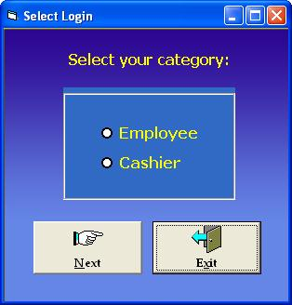
(Figure 1 – frmSelectedLogin)

In our inventory system, there are 2 selections when logging-in. To be able to go to the desired log-in, an option must be selected. If you click the Next button, an error message will appear indicating that you must select an option first before you can proceed to the Inventory System. You can’t continue to the system without selecting any option. If you click the Exit button, a message box will appear that ask a question if you really don’t want to enter the Inventory System.
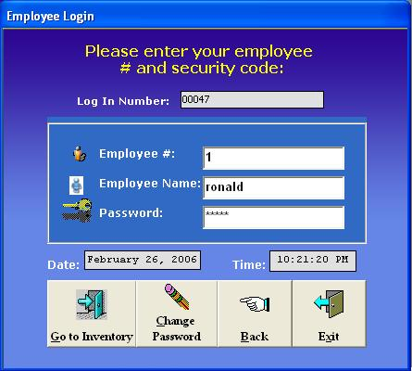
(Figure 2 - frmEmployeeLogin)

If you choose to login as an employee, it requires employee number, name, and password. If the input is incorrect, a certain error message will be displayed. You can’t continue to proceed to the main Inventory System if password is incorrect. If you want to change the selected log-in, click the Back button. If you don’t want to continue, click the Exit button.
If you were already logged in, the system will automatically update the employee login database as can be seen in the Employee Login Report.


(Figure 3 - frmLoading)

In this part the system loads the interface of the Inventory System.

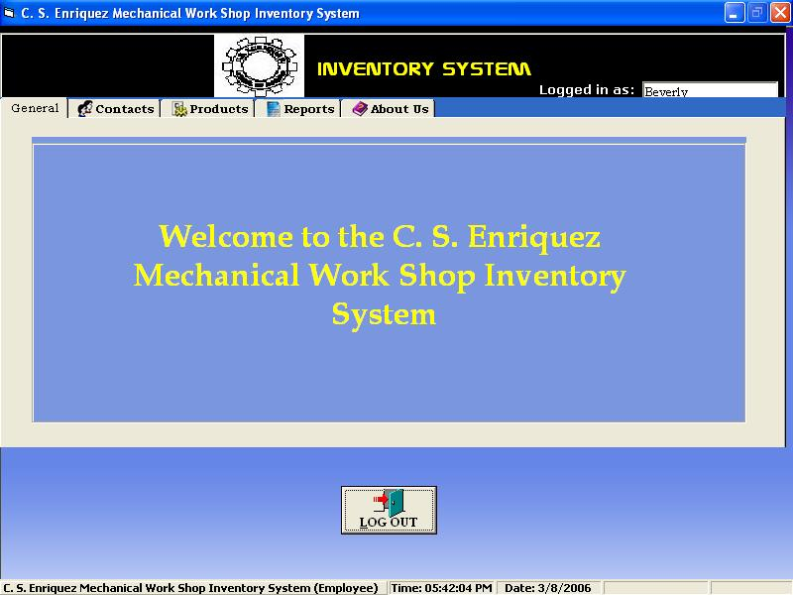
(Figure 4 – frmMain - General)

This form is the default form that can be seen every time you enter the Employee login. In this form the name of the Accounting Clerk can be seen in the upper right corner.
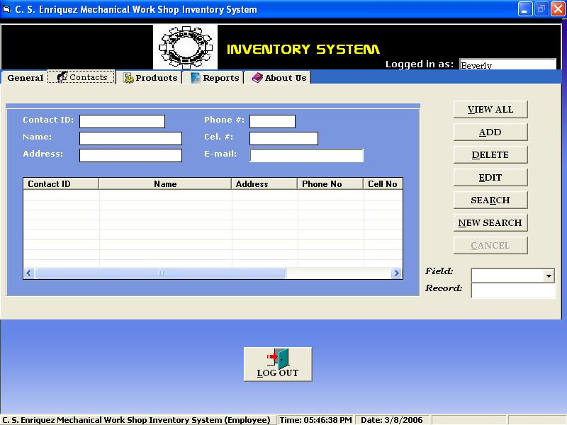
(Figure 5 – frmMain - Contacts)

In this tab, the accounting clerk can add, delete, edit, search and view all the clients’ contacts. As the accounting clerk of the company makes changes to the client’s contact the database of the system is automatically updated.
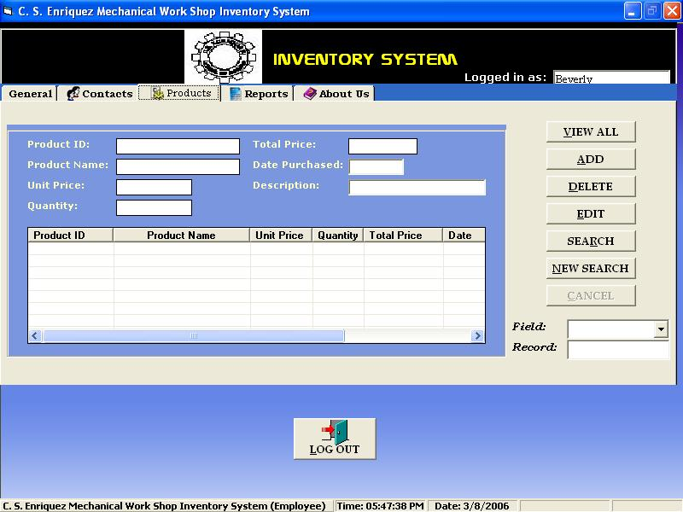
(Figure 6 – frmMain - Products)
In Product tab, the accounting clerk can add, delete, edit, search, and view all the products available in the company. As the accounting clerk of the company makes changes to the product descriptions the database of the system is automatically updated.
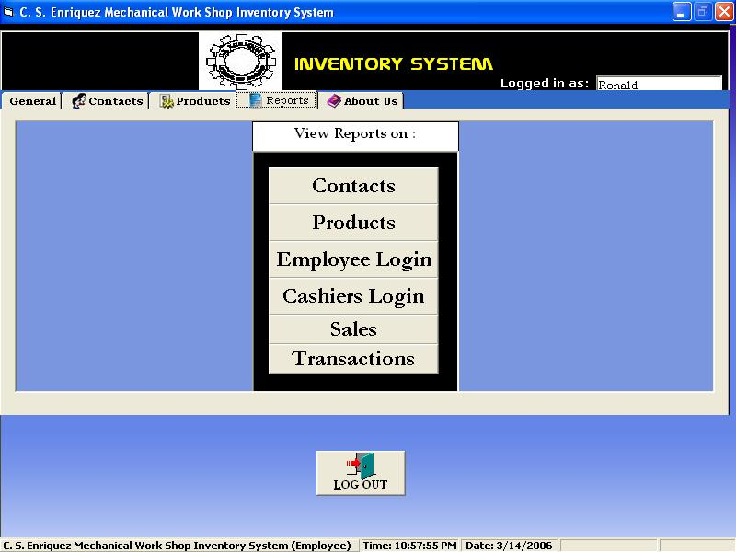
(Figure 7 – frmMain - Reports)

This tab has six buttons to choose if the accounting clerk wants to print the Inventory report of the company. In this tab, the clerk can view the contacts report, products report, login reports, sales report and transaction report.

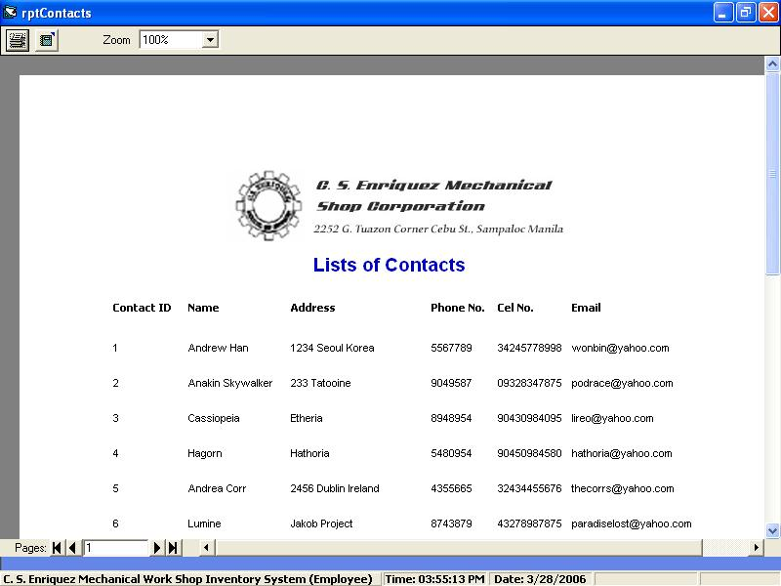
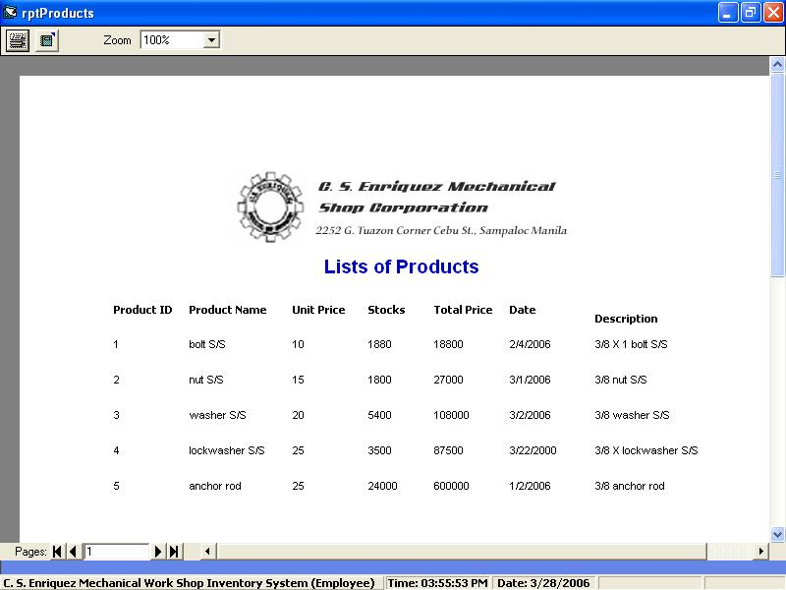
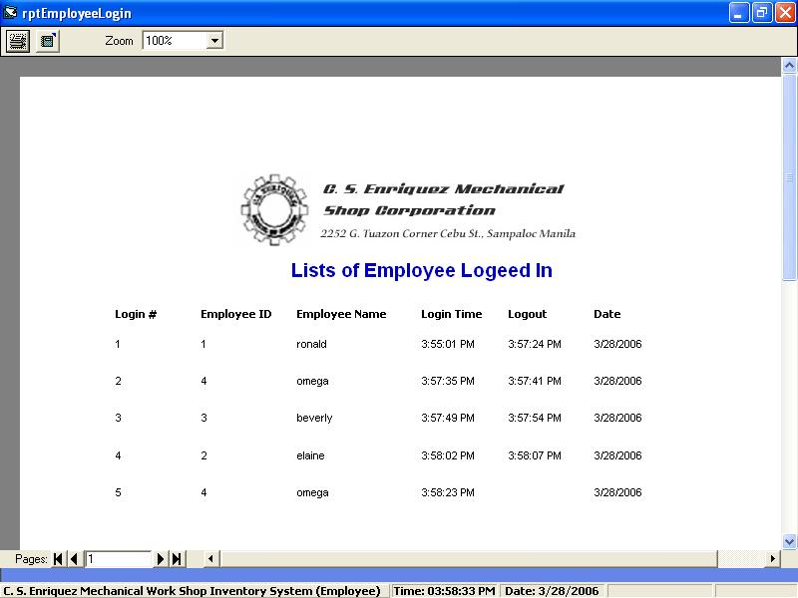
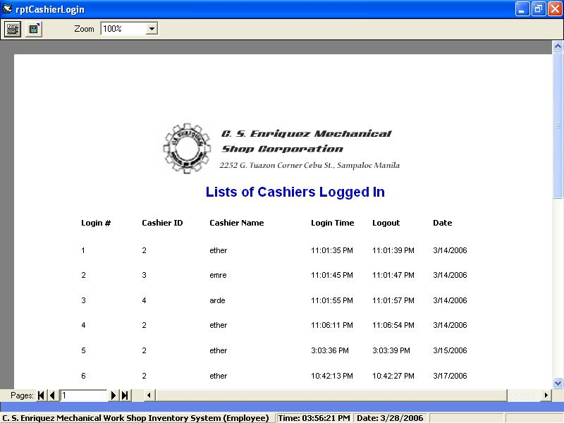
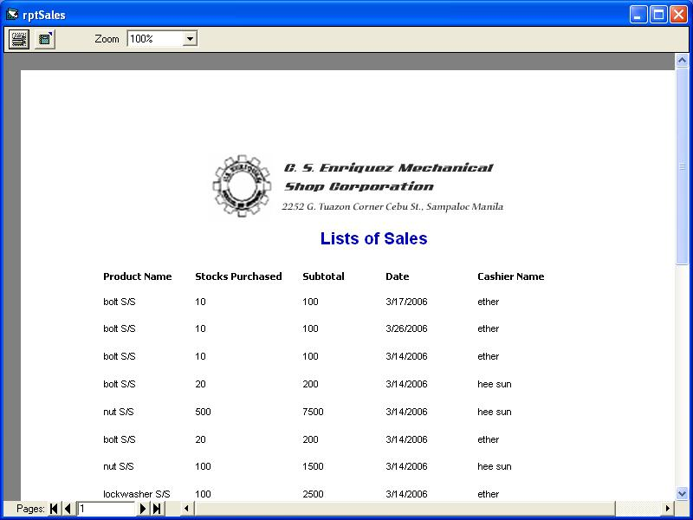
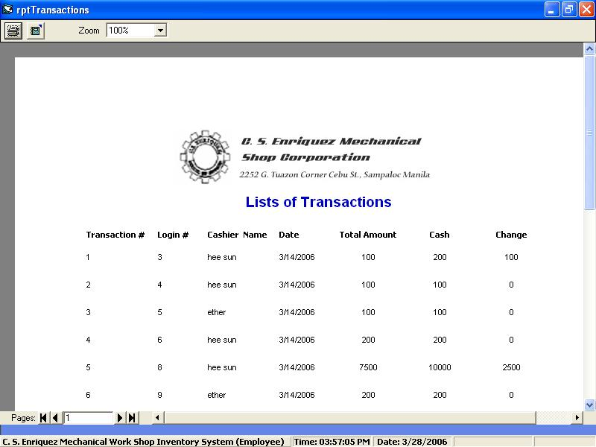

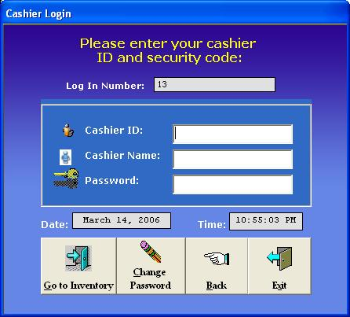
(Figure 8 – frmCashierLogin)

In this form, the system requires the company to enter the cashier ID, cashier name, and cashier password to proceed to the Inventory System.

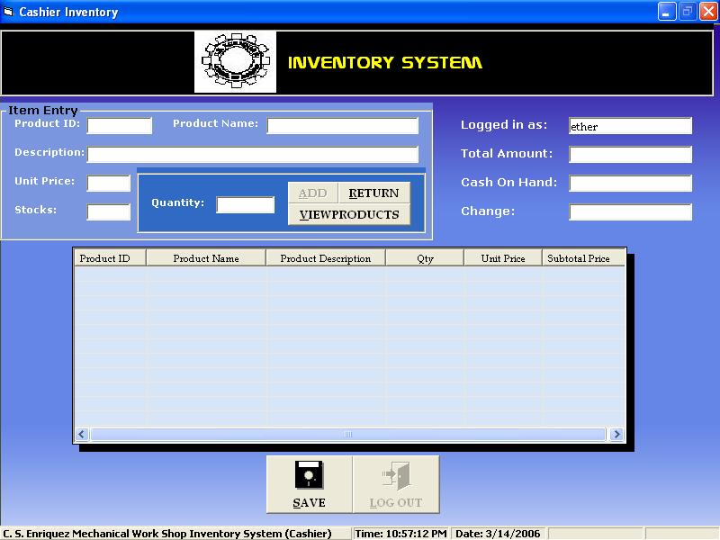
(Figure 9 – frmCashierInventory)

We include point of sales in the Inventory System in cashier login to easily update the product stocks and to easily monitor every transaction made. The cashier is not allowed to edit the products information. The cashier can only view the products information and make transactions.

INSTALLATION PROCEDURE

- Double click the setup icon.
- Wait for the Inventory Installation program to load.
- Follow instructions of the setup bootstrap in the Inventory Installation program.
- Exit setup if the installation is done.
- Exit Inventory Installation program.

HOW TO USE

- Select login, if cashier login or employee login
- For employee login, enter employee number, name and password. For cashier login, enter cashier ID, name and password. (Password is a must.)
- To see all the product and contact lists, click the View All button in the Main Inventory.
- To view the report, select from contacts, products, employee login, cashier login, sales, and transaction button.
- To print report, make sure that the printer is connected to the CPU and click the print icon.
- To exit, click the log – out button, a message box will be displayed, then click yes.

ERROR MESSAGES AND RECOVERY PROCEDURES

- Select Login
  - No Selection

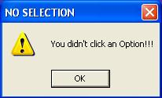

  - Exit

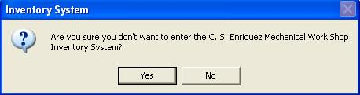

- Employee / Cashier Login
- Access Denied

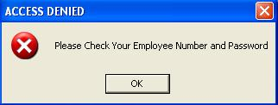

- Change Password

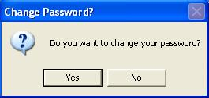

- Exit Inventory

- Main Inventory (Employee Log-in)
- Contacts

- Add Record

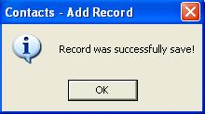

- Cancel Record

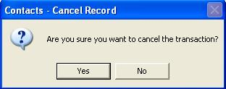

- Confirm Add Record

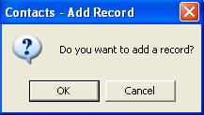

- Confirm Delete Record

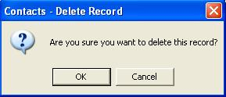

- Confirm Edit Record

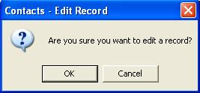

- Delete Record

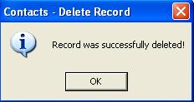

- Edit Record

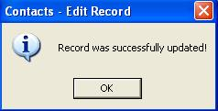

- Incomplete Data

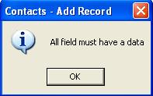

- No Delete Record

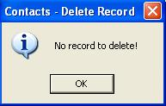

- No Edit Record

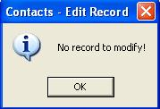

- No Search Record

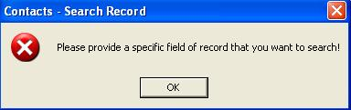

- No Search Record Found

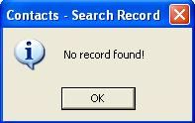

- Products

- Add Record

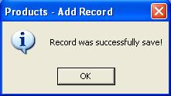

- Cancel Record

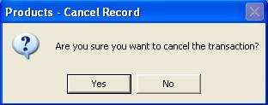

- Confirm Add Record

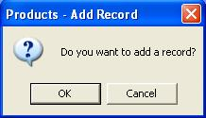

- Confirm Delete Record

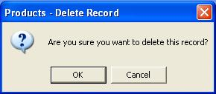

- Confirm Edit Record

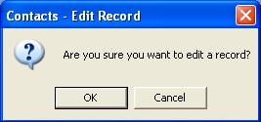

- Delete Record

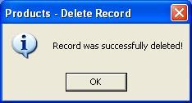

- Edit Record

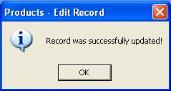

- Incomplete Data

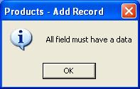

- No Delete Record

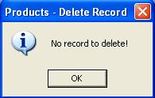

- No Edit Record

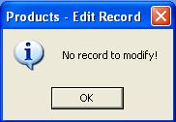

- No Search Record

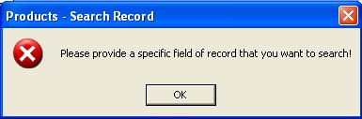

- No Search Record Found

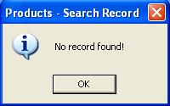

- Invalid Date Purchased

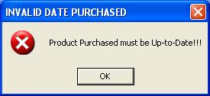

- Inventory (Cashier Log-in)
- 10% Discount

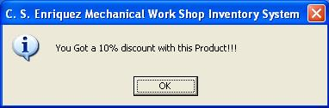

- Confirm Transaction Save

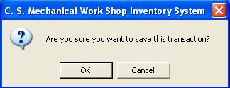

- Transaction Saved

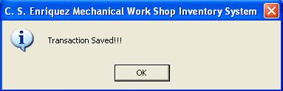

- Confirm Product Return

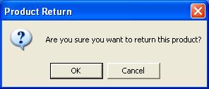

- Product Return

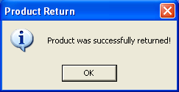

- Same Product ID

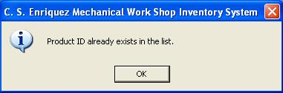

- Inappropriate Quantity

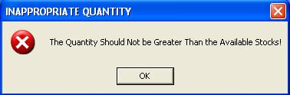

- Insufficient Stocks

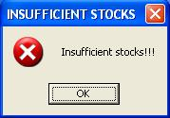

- Invalid Cash Amount

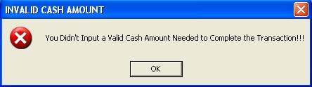

- Invalid Quantity

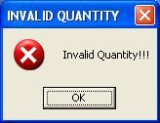

- No Product Return

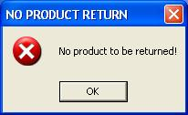

- No Total Amount

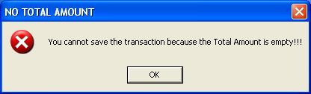

- Wrong Payment

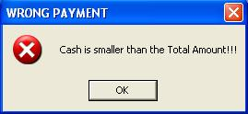

MINIMUM SYSTEM REQUIREMENT

- Screen Resolution: 800 x 600
- Color Quality: medium (16 bits) or highest (32 bits)
- OS needed: Microsoft Windows 98/2000/XP
- Memory Size: 16 MB RAM
- CD Drive: 4x Speed CD-ROM Drive
- Microsoft Visual Basic 6.0
- Microsoft Access 97 or higher version

